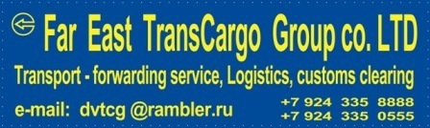
Dear sirs!
We direct you presentation of our company in which it is in detail specified:
- Our place an arrangement;
- Services offered by us;
- Our requisites. 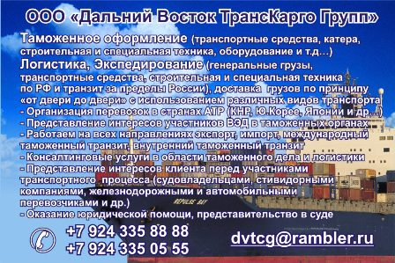
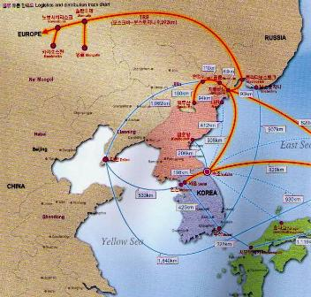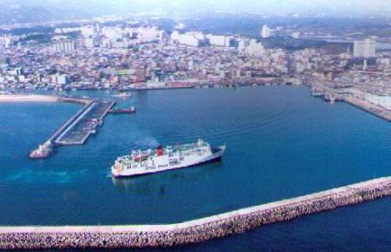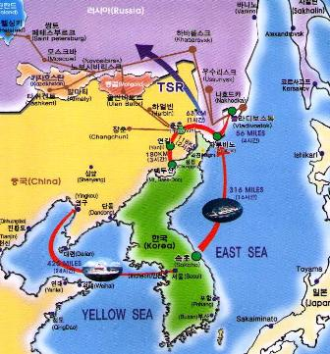
A. Logistichesky a route «Korea - Europe» Б port Sokcho South Korea в. Logistical route «Korea - Europe»

. - about us:
"Far East TransCargo Group, ltd"
Address: 692701, Russia, Primorski region, Hasansky area
t. Slavyanka, street 50 years of October 6 – 110. INN/KPP 2531010360 / 253101001, OGRN 1092502000140 A/C: 40702810545520000047
e-mail: dvtcg@rambler.ru mobile phone + 7 924 335 88 88, + 7 924 335 0 555.
Аdditional office № 4552 Slavyanka Primorskiy branch of ОАО Akb "ROSBANK"
Vladivostok,Russia, inn7730060164, A/C 40702840845520000005

"Far East TransCargo Group, ltd"
- Customs registration, logistics, transport-forwarding service across Russia and behind its limits.
- Delivery of cargoes by a principle from a door to a door, transport any kinds.
- The organisation of transportations in the countries of Asian-Pacific region.
- Representation of interests in customs and other state structures.
- We work on all directions (export, import, transit).
- We render consulting services in the field of customs business and logistics.
- We represent interests of the client before participants of transport process.
- We render a legal aid, representation in court.
- We are in Sea port Zarubino
2. - our site:
Our office is located in sea port "Zarubino" (Open Society «Seaport in the Trinity bay»). The port is located in such a manner that to the international check point with China ( «to Kraskino - Hunchun») – 75 kilometres that allows us to accept, spend customs registration and to direct by rail any cargoes.
The specified port is connected by regular sea ferry lines of the company «Dong - Chun» on мартшрутам:
A. Sokcho (South Korea) – Zarubino (Russia) – 3 times a week.
B. Sokcho (South Korea) – Niigata (Japan) - Zarubino (Russia) – 2 times a week.
So the basic our plus is the site – what as a result to become our advantage expressed in:
- Speeds of delivery and processing of cargoes, (whether it be delivery in Moscow or a cargo direction in a mode of the international customs transit to Kazakhstan, Uzbekistan, Belarus and so on ….)
- Speed and quality of customs registration;
- Higher quality of all services given by us.
On the enclosed schemes routes of ferries are visible.

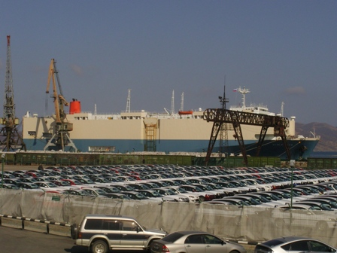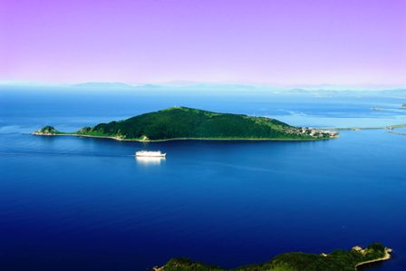
1. Port " Zarubino " 2. The ferry «Dong - Chun» is included into port " Zarubino "
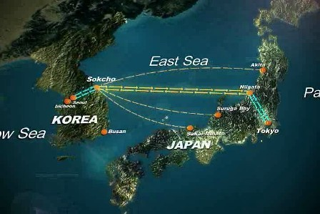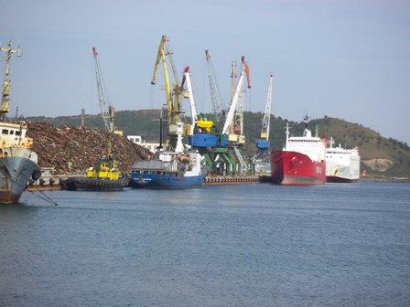
3. The scheme of movement of the ferry on a route: «Sokcho - Niigata» 4. "Zarubino"
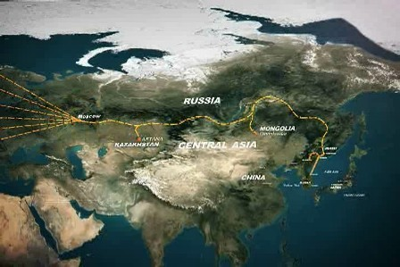
5. The scheme of a direction us of cargoes by rail from port " Zarubino"
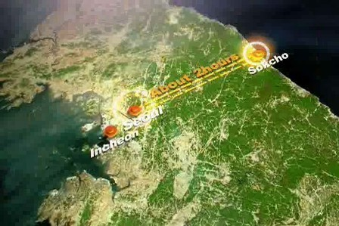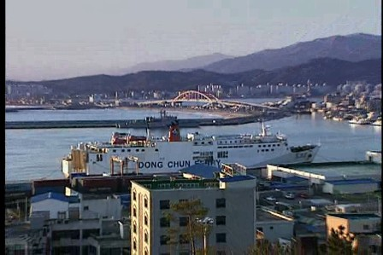
6. From Sokcho to capital of South Korea of Seoul - 2 hours of driving on the car 7. The ferry in port Sokcho RK
8. Photos of the arrived ferry. 9. The dredges which have arrived on the ferry
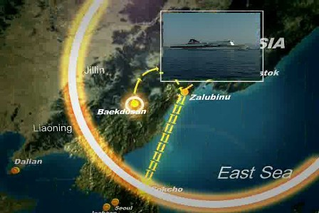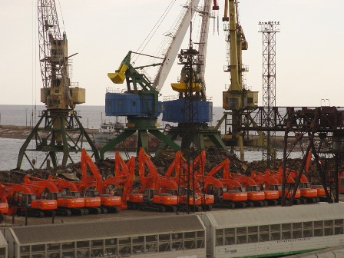

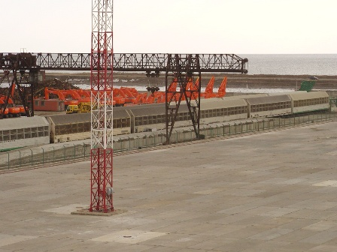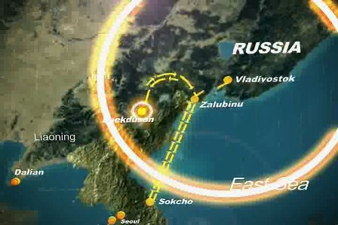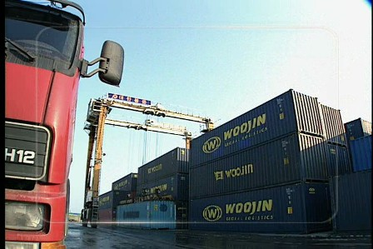
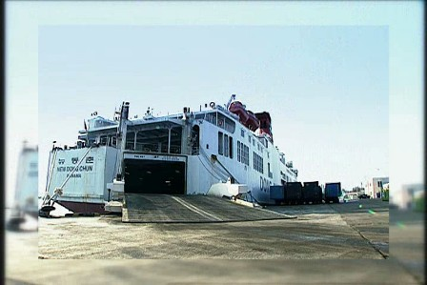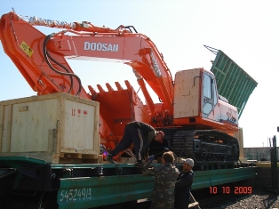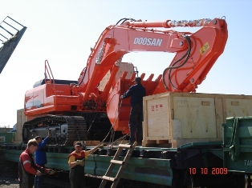
Yours faithfully and hope of mutually advantageous cooperation!
Open Company "the Far East the Trance of the Cargo of Groups"
WWW.FETCG.NAROD.RU
e-mail: dvtcg@rambler.ru + 7 924 335 88 88,
+ 7 924 335 0 555.

